**User Management Application**

This application is built on Gradle with H2 Local File as Database so that It would be a plug and play in any systems.

**Rest End Points build. (below is snap shot from Swagger)**

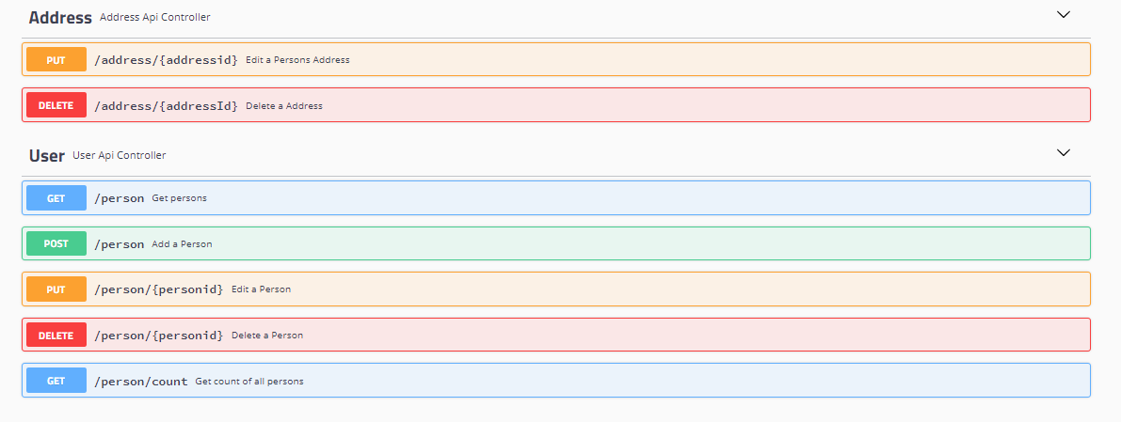

The swagger is also integrated and can be accessed at :  
<http://localhost:8080/usermanagement-api/swagger-ui.html>

To build the project please use :   
**gradle clean build**.

And to run the application use:

**java -jar build/libs/usermanagement-0.0.1-SNAPSHOT.jar**

To test the application you can test each end point from swagger when the server is started or you can use the below postman collection.json file.



Please mail or contact me if any issues.